CODE:

import pandas as pd

import matplotlib.pyplot as plt

roles=['Data Scientist ','Data Engineer ','Data Analyst ',' Business Analyst ','ML engineer']

Count=[100,150,200,250,300]

df=pd.DataFrame(data)

plt.bar(roles,Count,width=0.3)

plt.title('Trends of Data Science Job Postings')

plt.xlabel('Roles')

plt.ylabel('Number of positions')

plt.show()

OUTPUT:

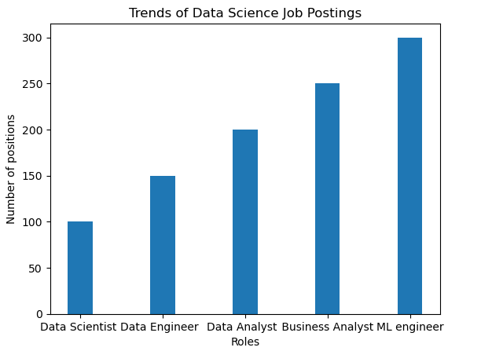

CODE:

import matplotlib.pyplot as plt

roles=["Data Scientist","Data Engineer","Data Analyst","Business Analyst","ML Engineer"]

count=[20,30,17,35,23]

plt.pie(count,labels=roles)

plt.show()

OUTPUT:

